Unit 4 - Worksheet 5

Electric Force and Electric Field

For the following questions, use your knowledge of field forces to determine the answer. Show your work and include units.

1. a. An object has a charge of +2.0 μC. What is magnitude of the electric force on the object by an electric field of 5.0 N/C?

b. How does the electric force differ if the object had a charge of -2.0 μC?

1. A uniform electric field of 4.5 N/C is shown to the right.

a. What charge must be placed in the field to experience a 13.5 N force *up*?  
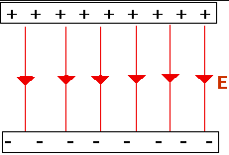

b. What charge must be placed in the field to experience a 13.5 N force *down*?

1. A tiny oil drop of mass 3.5 mg holds a negative 2.5 μC charge on Earth (*gEarth* = 9.8 N/kg). What electric field must exist where the oil drop is being held, in order for the oil drop to hover in place at rest?
2. If the previous scenario were to take place on the moon (*gMoon* = 1.6 N/kg), rather than the Earth, how would the situation be different? Calculate the electric field, if possible.
3. If Robert Millikan were conducting his experiment on the moon rather than the Earth, how would it have changed his findings? Would the charge of an electron have been different? How would his experiment have been different?

1. What similarities are there between electric fields and gravitational fields? What is the biggest difference between gravitational and electric fields?